Wizard driven portal: First screen

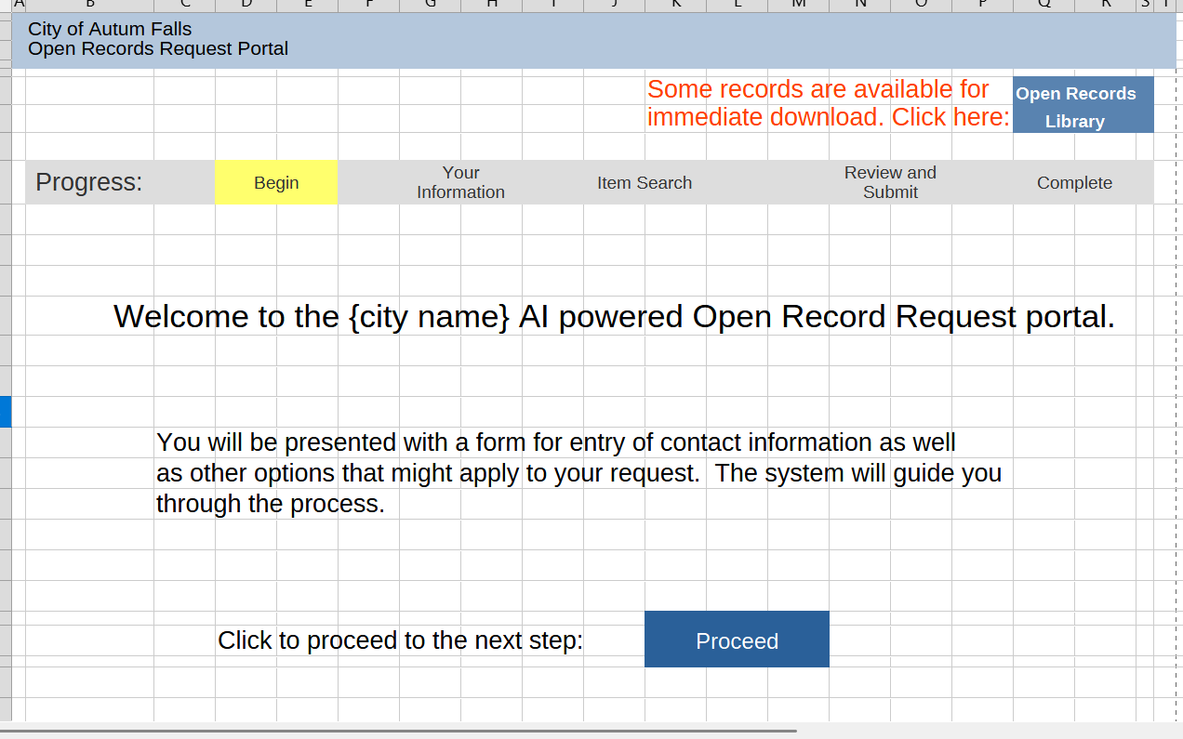

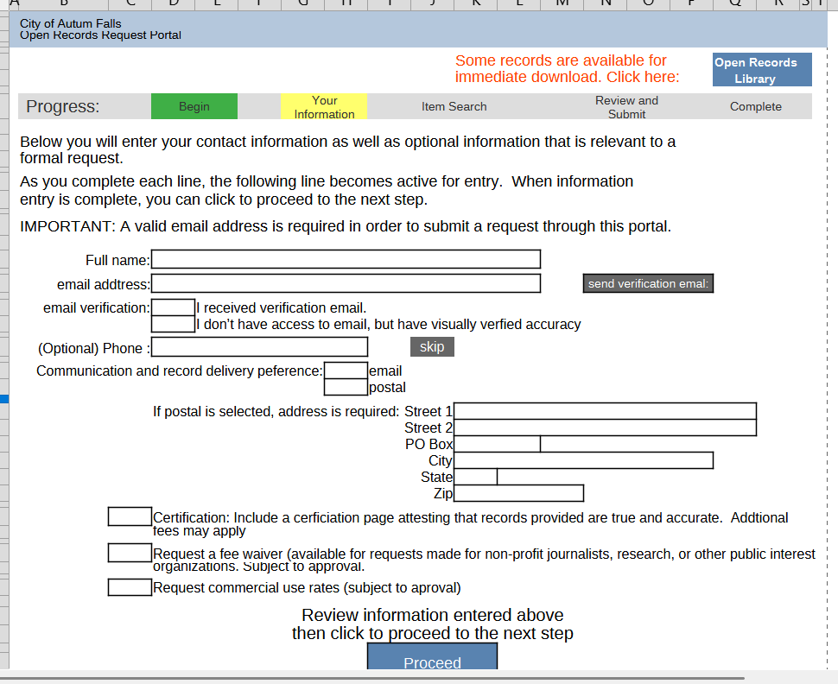
Clicking Proceed takes requestor to second screen. Everything below send verification email should be grayed out/locked until Send Verification email is clicked. That unlocks what should be buttons allowing click to indicate email verification received and a button that indicates email address visually verified. Clicking either unlock phone number, skip button, and choice to select email/postal section. If postal is selected, display address info box. When either postal or email is selected for simplicity go ahead and unlock the three select options.

Clicking proceed on prior screen takes requestor to the item search instruction screen.

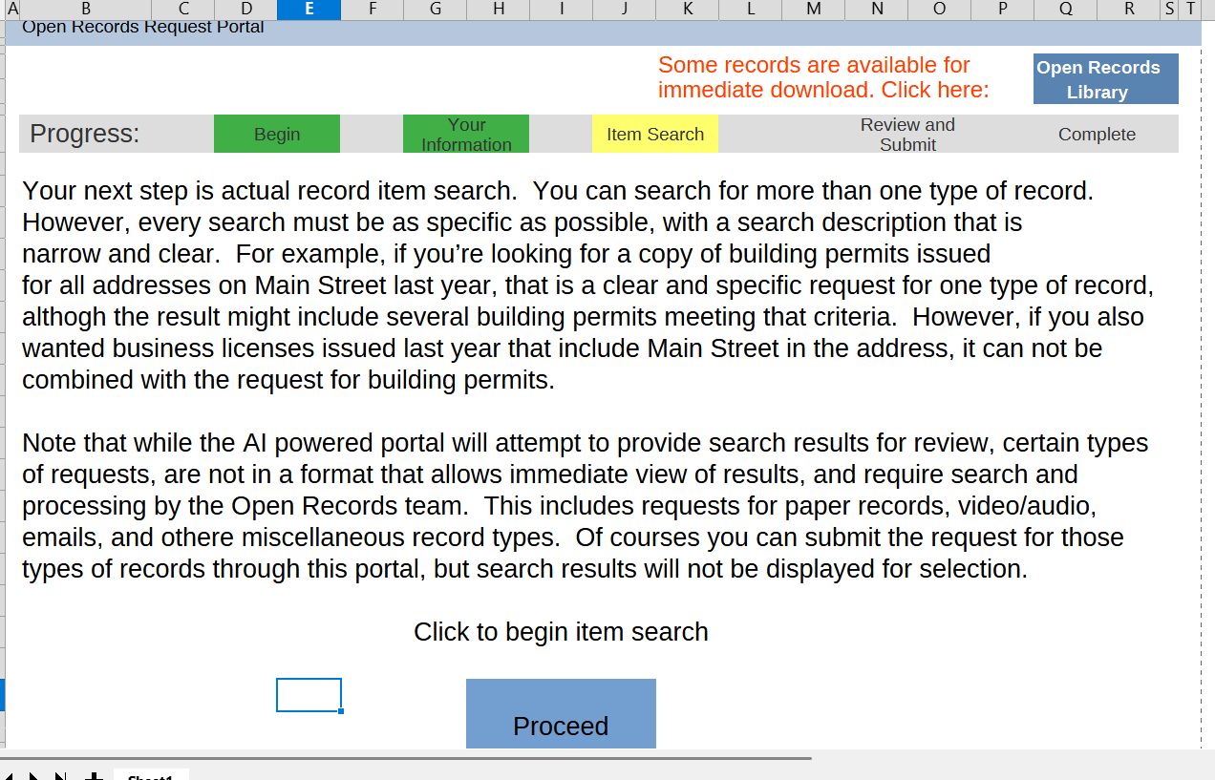
Clicking proceed on the item loop instruction screen takes requestor to item loop first screen

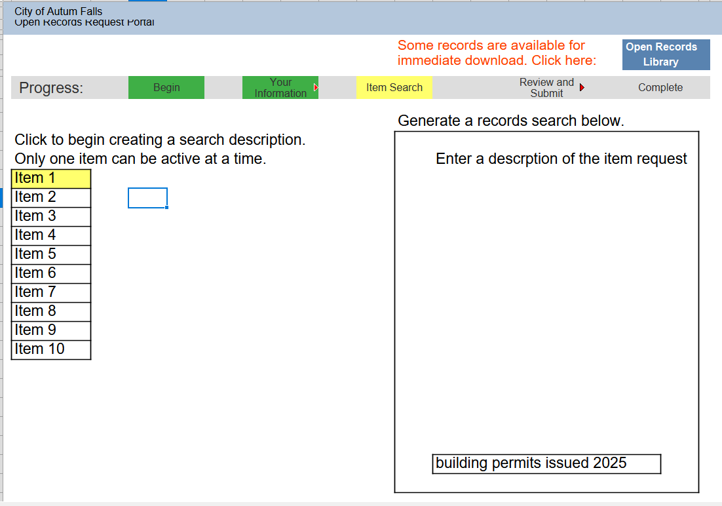
Note that the on screen instructions indicate that the requestor should click an item to begin. This should ber changed. This is the beginning of a loop, and the system should highlight Item 1 on the first iteration automatically, and if the user chooses to add another item at the end of the loop, the current item is changed from yellow to green and in this hypothetical, item 2 would become yellow as indicated in the screen at the end where the loop begins again. The on screen instructions should be changed to explain to the requestor that the description of the first item request should be entered in the agent prompt at the bottom of the AI chat message window.

After a description is entered, that agent proceeds to ask questions refining the search, asking for agreement when it feels it is time to submit (as it behaves currently), and when agreement is reached and submit for search begins, the agent hides. At this point there is a branch, one path is No matching results, the other is Matching Results Located. If no matching results, this screen appears.

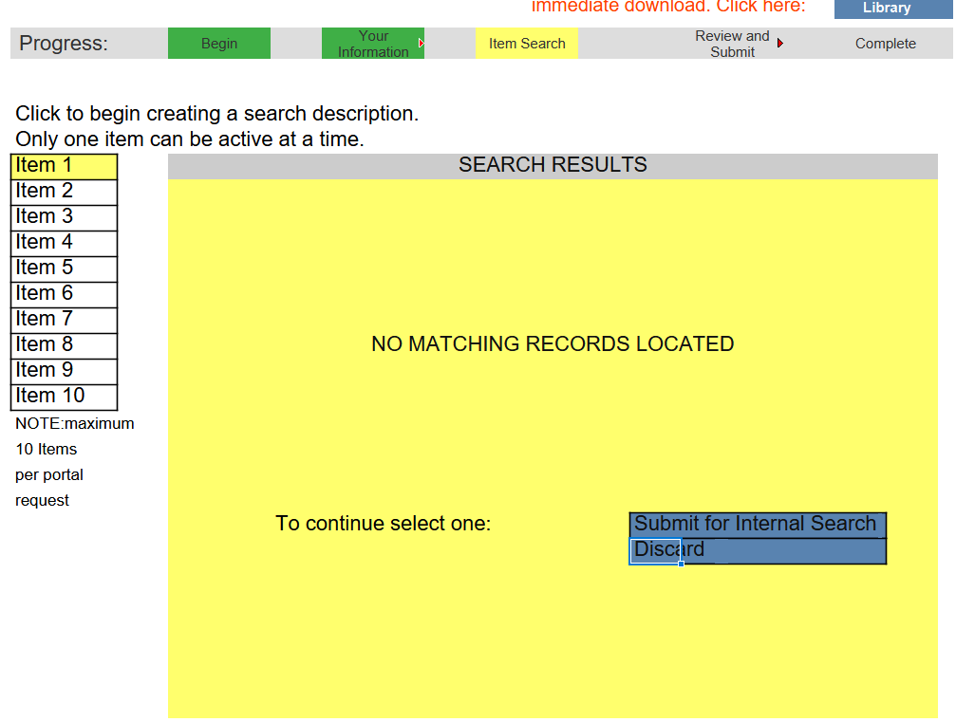

This screen needs further explanation on the UI to add clarifty for the buttons. Submit for Open Records team search would place an indicator to the right of Item one….something such as Extended Search Open Records Office….but this is too long. Discuss. Discard would place an indicator to the right of item 1, Discard.

If records are found, this screen appears:

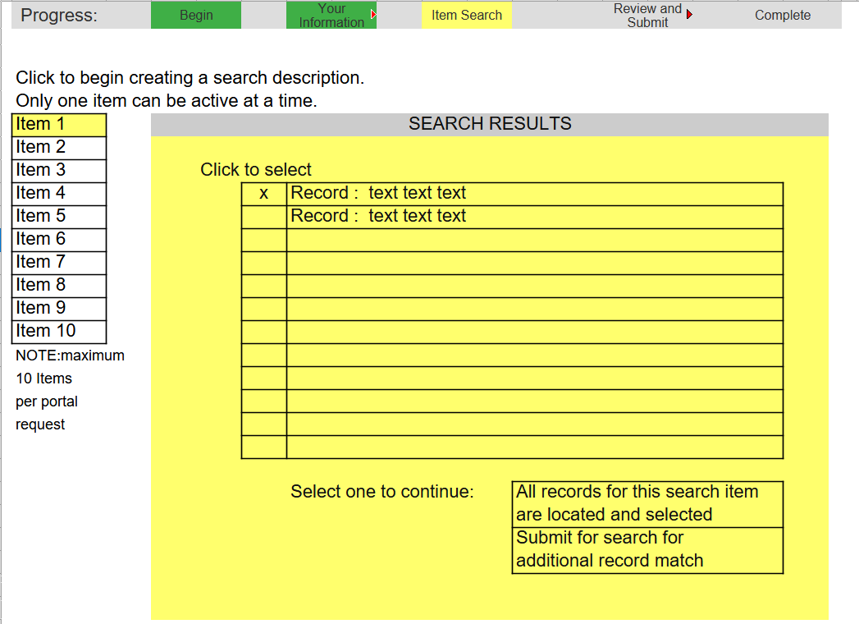
Selecting the top button, all records for this search item are located and selected...marks item 1 as complete to the right of the item 1 block. Submit for additionl record match (wording here needs to match that on button with similar intent on No Matching Results screen...also, the “buttons” here should have been blue….all buttons in this buuild should be blue).

Clicking any of the options for the prior two screens (one scenario where no records are located in system search, the other where records are located) will take the user to a screen which forces selection indicating intent to add another search item, or that the entry of search items is complete.

BRANCH END SCREEN

Note that descrptions should appear next to completed items after clicking any buttons on the two screens above...I failed to display an example here but there is an example on the prio

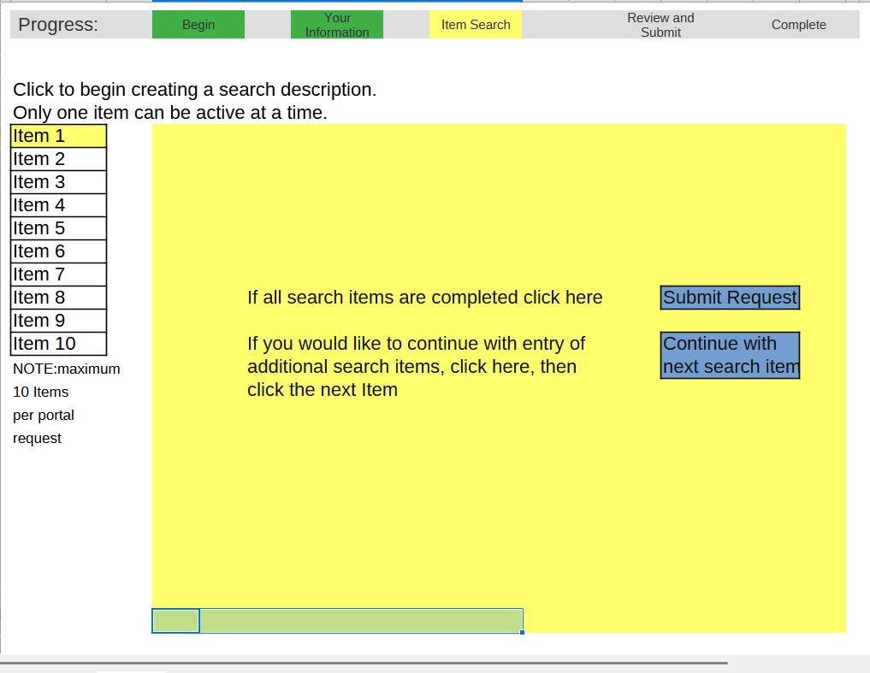
The words used above might need to be refined for clarity but this is the SUBMIT OR CONTINUE LOOP screen.

Clicking submit button above submits the request, displays a confirmation screen with request numberr and text indicating confirmation will be emailed.

Clicking to continue with next search item goes back to the initial screen in the item loop, with the next item highlighted,

Begin item loop again

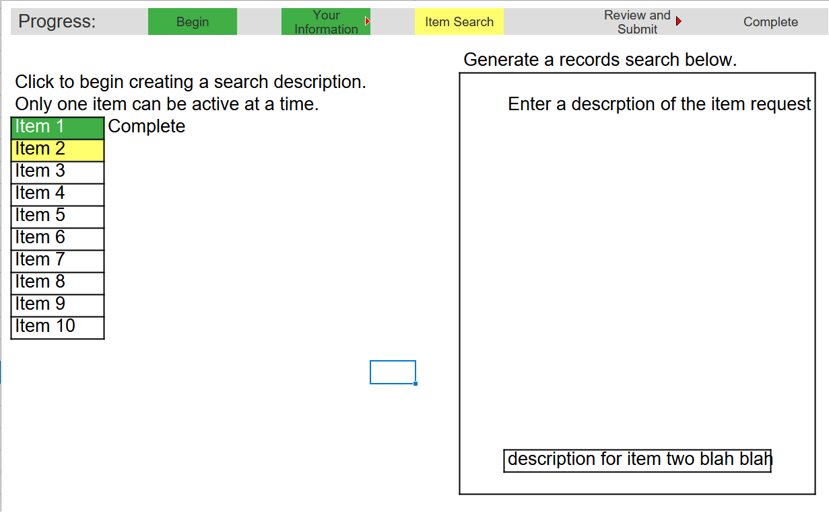

First comment: the progress bar does not map to the flow. I originally intended to have another screen like nothing we currently have, which would show something like a full document that would resemble a complete form containing all info of the request. This would be generated by clicking what is now the SUBMIT REQUEST button on the SUBMIT OR CONTINUE LOOP screen, with that button instead saying SUBMIT REQUEST FOR REVIEW. Then when the document type view appeared, a button to submit, a button to edit personal information or options, and a button to edit Search Items. But, I think this would mean significant additional screen design and code modification, so for SUBMIT means submit, present screen with request number, etc and be finished. Perhaps revisit if customer feedback indicates I should. In any case, the progress bar should be changed to delete complete, and submit/review should bre changed to submitted. Since there is no “in progress” status for submit (it’s selected in the item loop, so it could change the Item Search to green and Submitted to green, but unless it is displayed on the screen showing confirmation of submission there’s no need to code color change for those nodes.

